Name_________________________________________________________Date________________Period___________

***Coordinate Area and Composite Figures***

**Directions: Solve each question and show all steps as if you didn’t know the answers. Make sure your answer matches the answer that is given in bold. If you have trouble, use your book, internet, or neighbor.**

Area of a rectangle: $A=b∙h$ Area of a triangle: $A=\frac{1}{2}b∙h$

Height is always perpendicular to the base in a polygon. Perimeter: Sum of the side lengths of the polygon.

**#1-5 Find the perimeter and area of each figure. Round to the nearest tenth if necessary.**

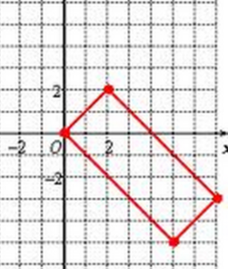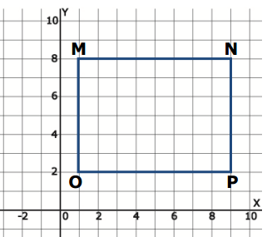

1. **2.**

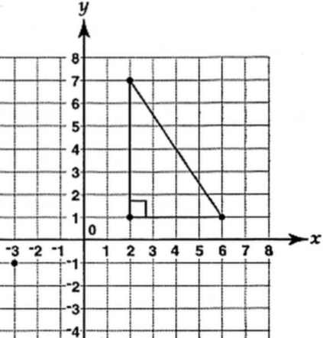

**3. 4.**



 5. 6. What is the perimeter of the figure?

6. Find the perimeter and area of a rectangle with vertices at *C* (-1, 1), *D* (3, 4), *E* (6, 0), *F* (2, -3). Round your answer to the nearest hundredth when necessary.

7. Calculate the area of triangle *ABC* with altitude *CD*, given *A* (-4, -2), *B* (8, 7), *C* (1, 8) and *D* (4, 4).

8. Why does area have square units and height and length do not? Your answer must be in complete sentences.

This is a different way you can find the area of a triangle if it does not have 1 horizontal side. <http://www.mathopenref.com/coordtriangleareabox.html>

Joke of the day: Johnny has 20 chocolate bars. He eats 18 of them. What does Johnny have now?

A serious problem.